**TECHNICAL DESIGN DOCUMENT**

Project Name : Capstore E-Commerce Application

Team Name : Raavan

Team Members:

1. Thatiparthi Adithya Teja Ashok Reddy - 46022671
2. Prithve Kumar P - 46022039
3. Syed Waseem Fahad - 46022135
4. Pasupuleti Sri Harsha - 46022099
5. Hitesh Varma Pakalapati - 46022674
6. Vamsi Krishna Damisetti - 46022686
7. Samayamanthula Sri Harsha - 46022101
8. Konduru Pravallika - 46022060
9. Sivaramakrishnan Tiruvengadam - 46022103

10.Mandapati Mahathi – 46022098

**Introduction**

Capstore is an e-commerce application from where users can buy products they desire. The capstore application has three actors in it :- Admin, Customer, Merchant.

**Functional Requirements**

**For Customer :**

1. Home Page
2. Product List
3. Product Details
4. Search and filtering
5. Similar Products
6. Cart
7. Wishlist
8. Place Order
9. Coupon validation
10. Invoice Generation

**Services**

1. **Customer Service**: This service is used by the customer for viewing and placing orders. This service also provides customer wishlist the product and to add to the cart.

**Sequence Diagrams**

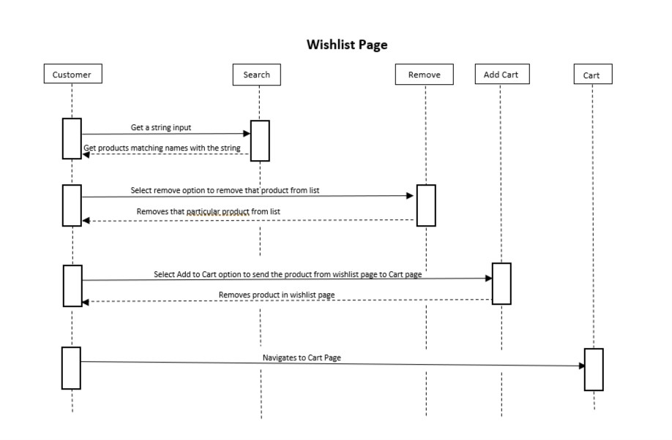

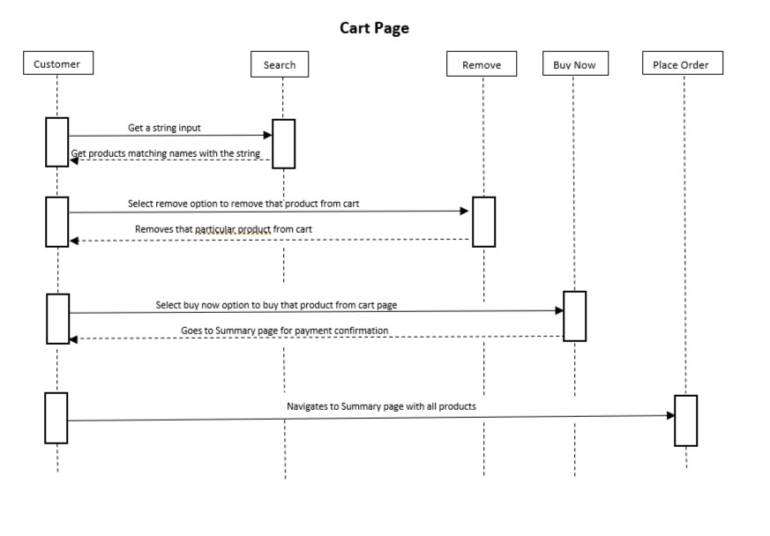

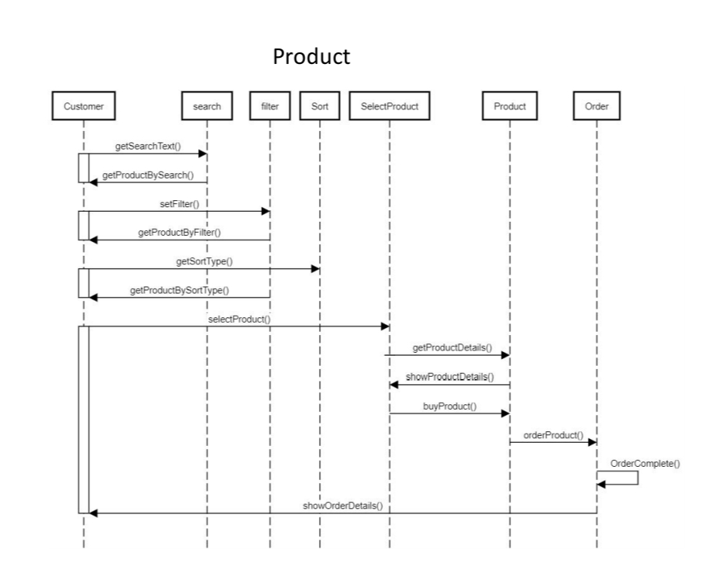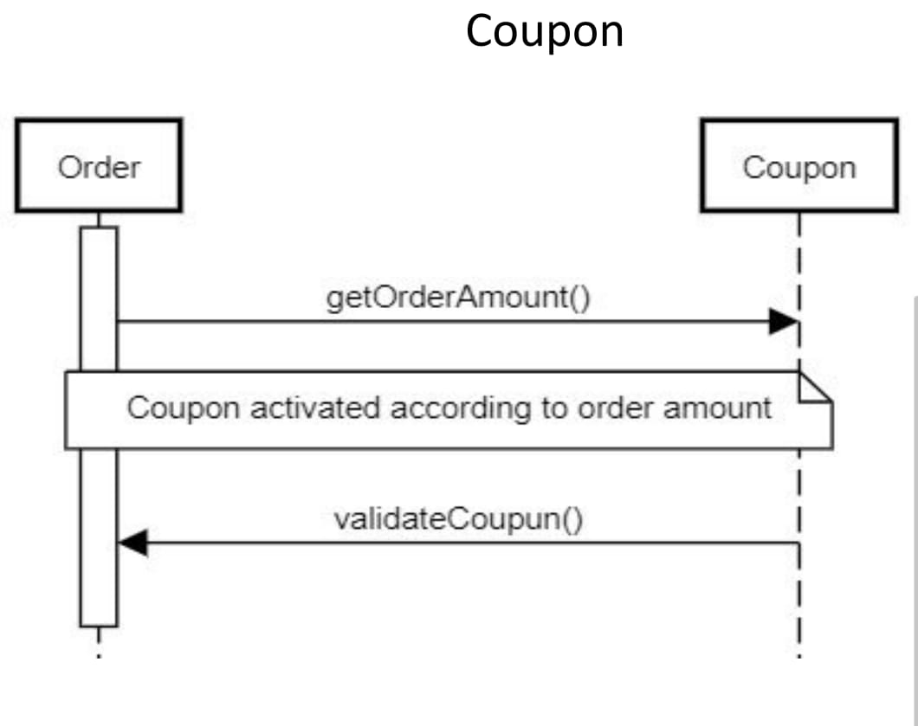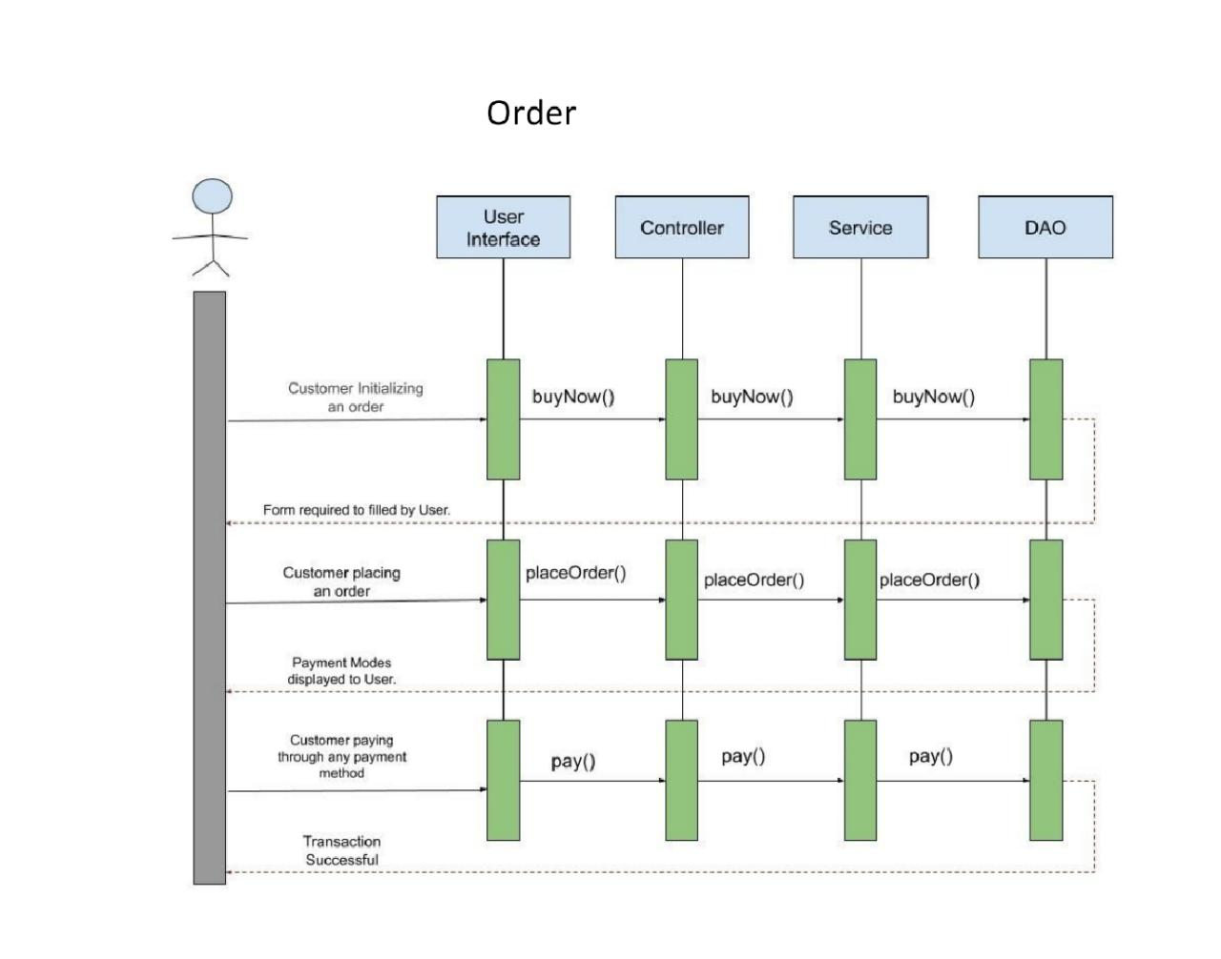­­­­

Activity Diagram

­­ 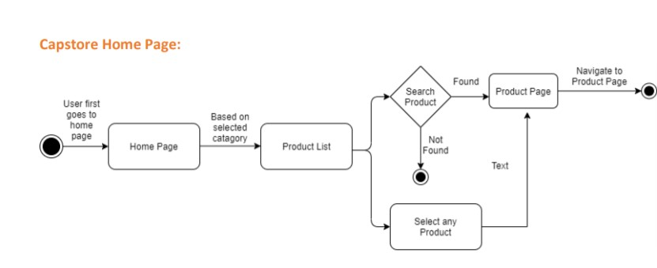

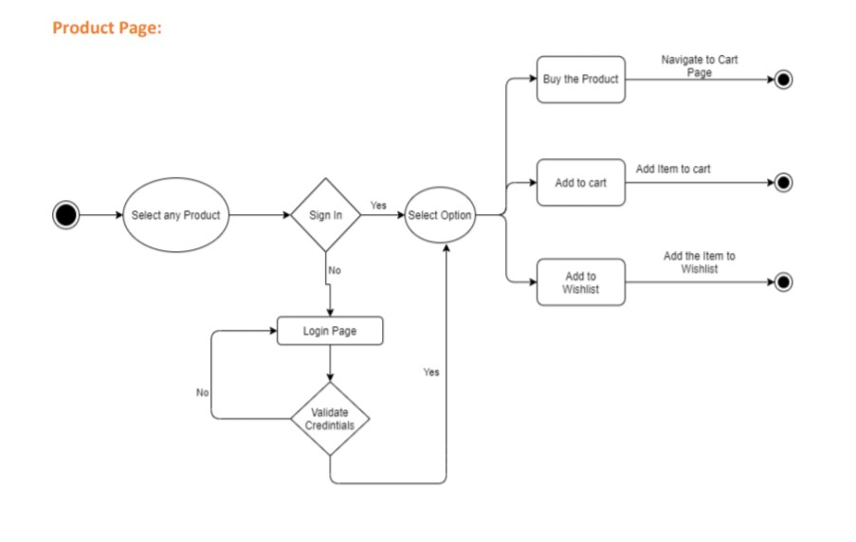

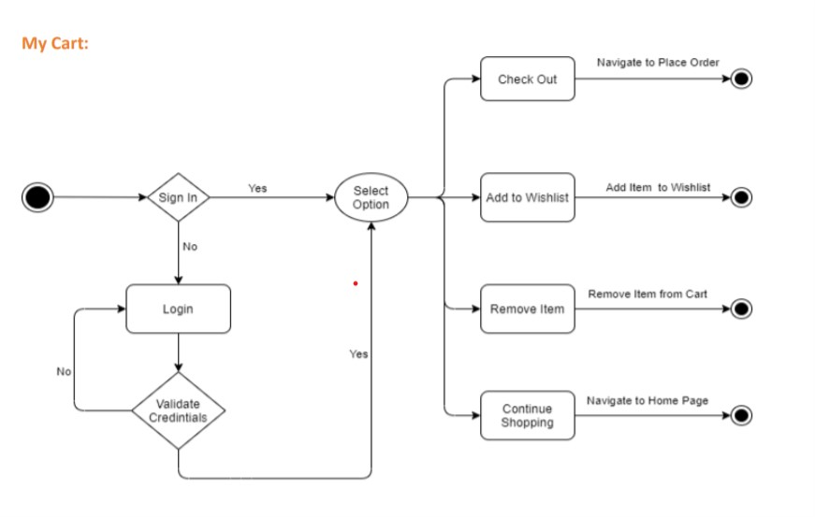

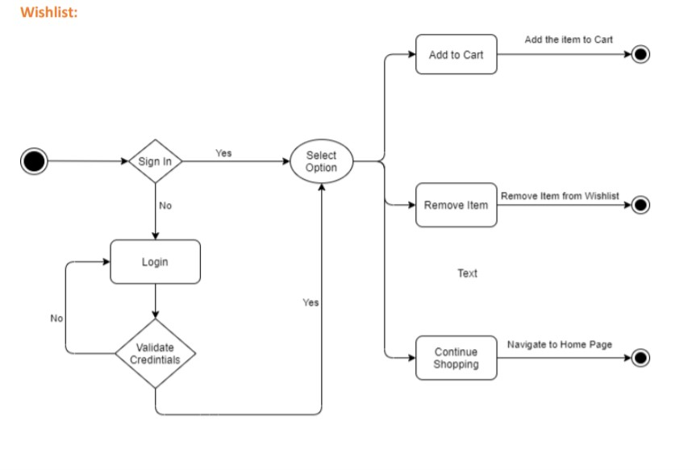

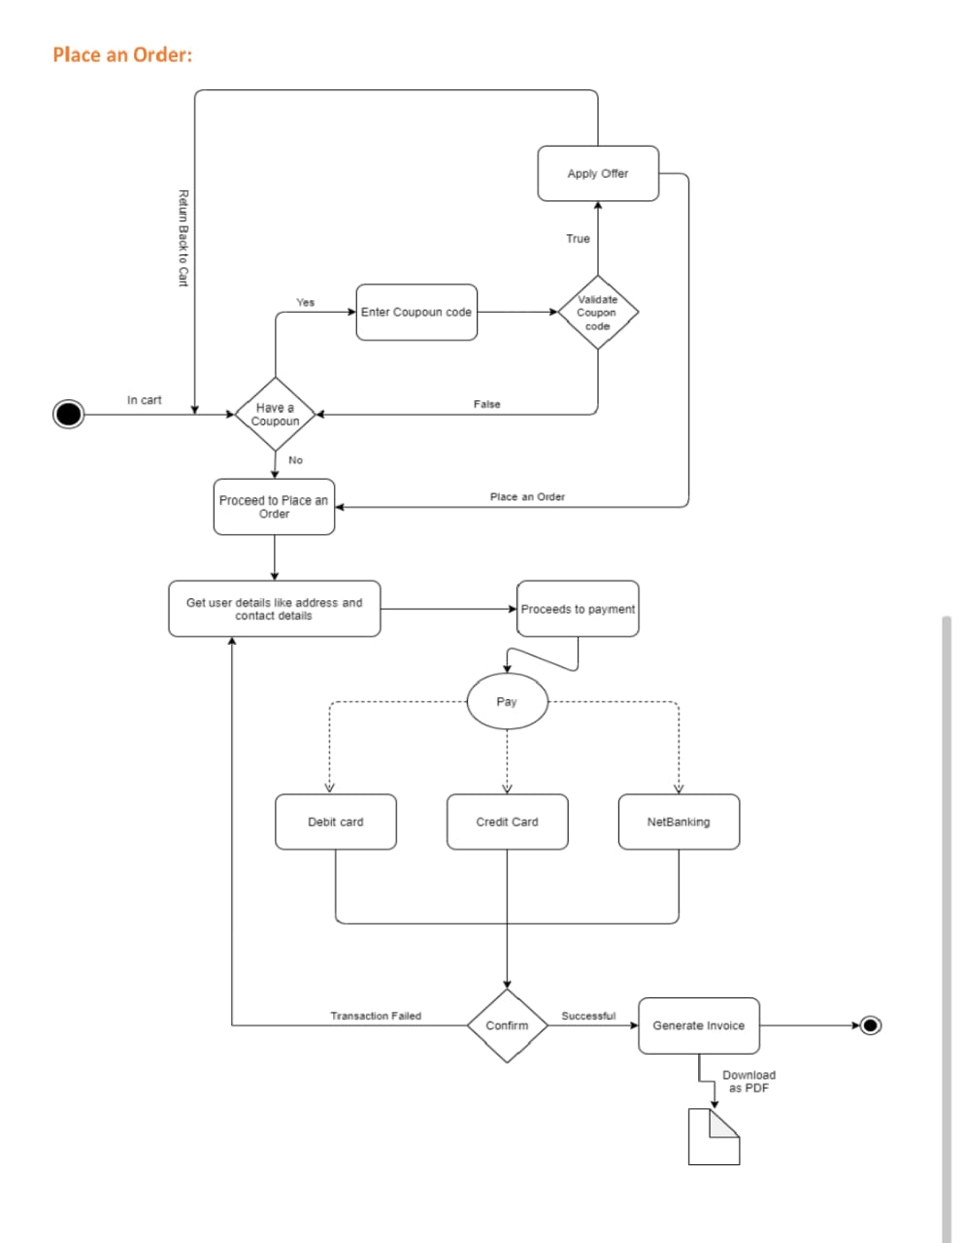

WIREFRAMES

